Data for this exercise: <https://drive.google.com/file/d/1_Zgi73vysPOzmVxziEiA5Fu7n_QPRZ1H/view?usp=sharing>

1. **Question:**

To the given data apply conditional formatting, if marks greater than 35 highlight it.

**Answer:**

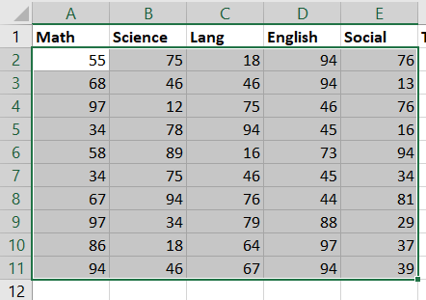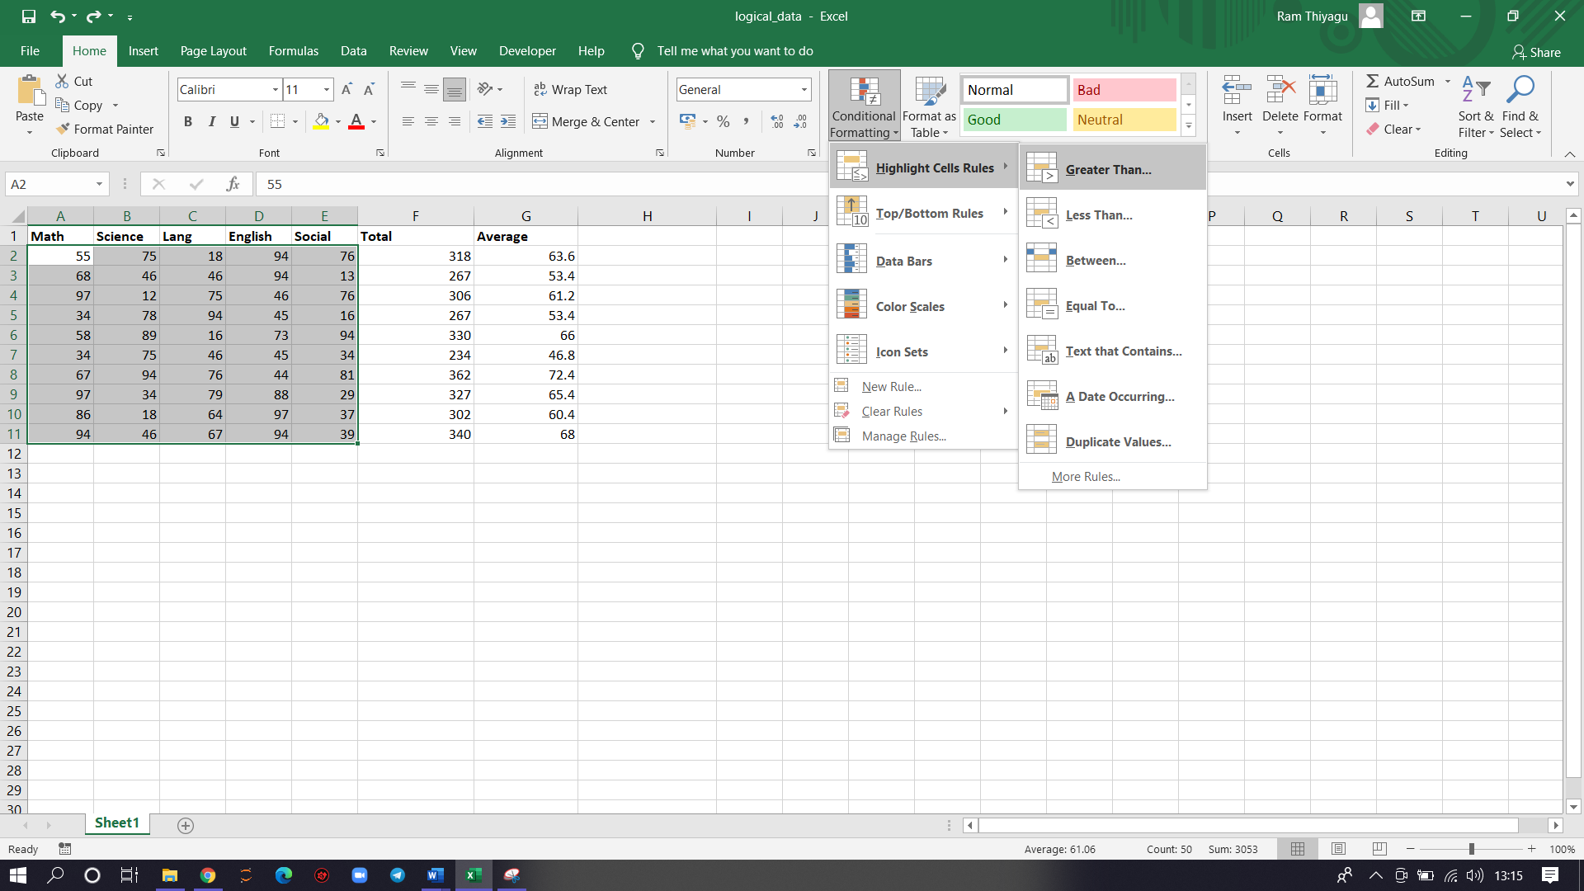

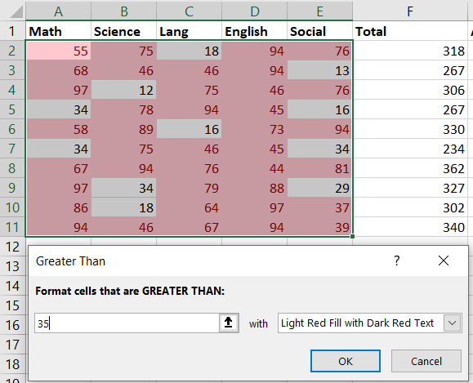

1. **Question:**

From the given data calculate the total for every students marks and highlight the top 3 scores by applying Top/Bottom rule in it.

**Answer:**

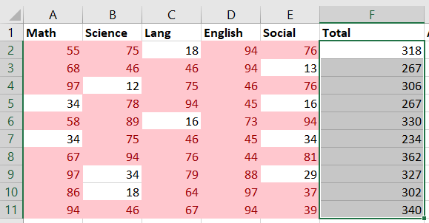 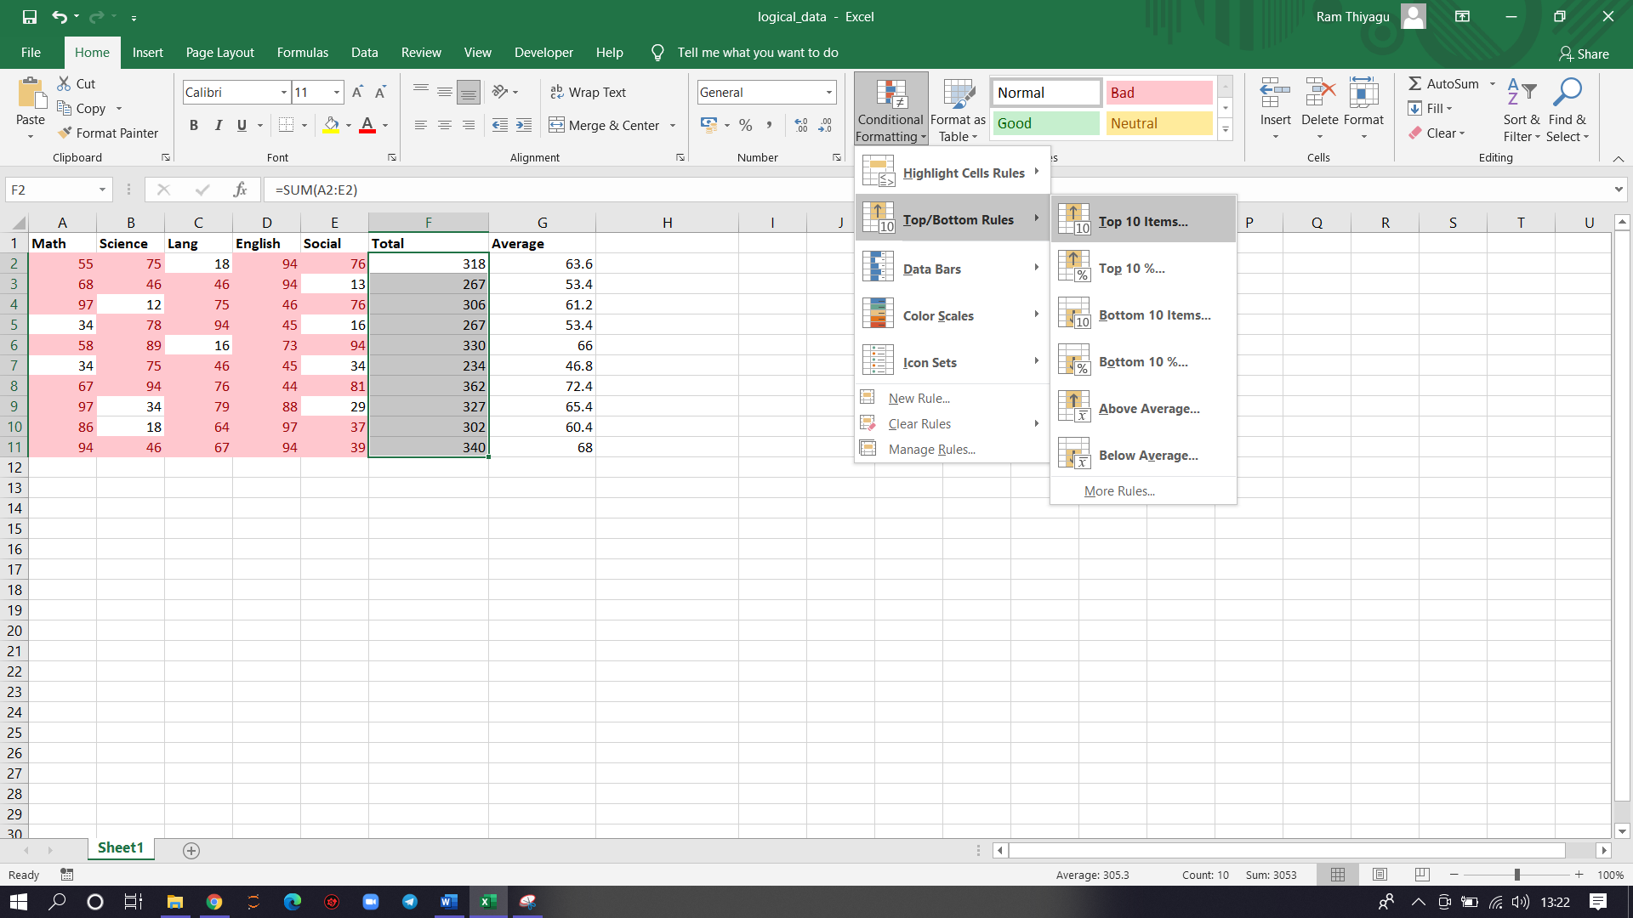

Conditional formatting >> top.Bottom rules >> top 10 items..

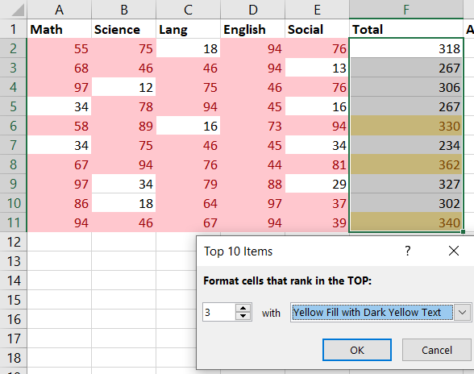

1. **Question:**

Find the average from the total marks and apply color scales in it

**Answer:**

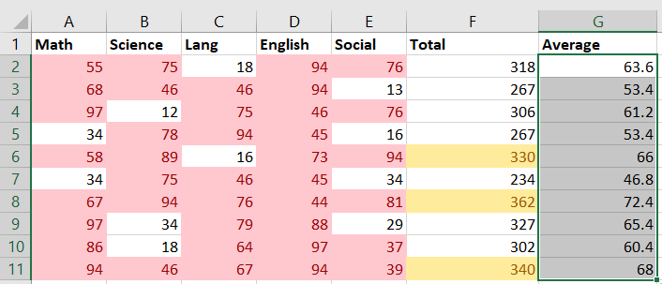

Conditional formatting >> color scales >> select color scale

